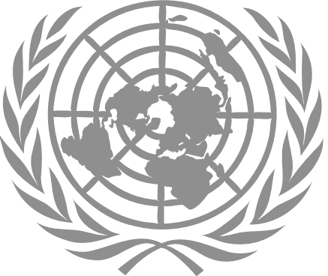
Entity level checklist
on the minimum actions required on the
protection from sexual exploitation and abuse
16 September 2022

Policy and entity oversight
- Ensure that the PSEA policies and other guidance that set out standards of conduct related to PSEA both at the entity level and in all duty stations are in place.
  - PSEA policies, including standards of conduct, and a work plan to implement the policies are in place.
  - PSEA policies are reviewed as required and senior management conveys any changes based on reviews to their personnel as appropriate.
  - Mechanisms are in place to regularly track the status of the implementation and uniformity of the PSEA policies by the UN Country Teams at the entity and at field levels.
  - The entity ensures that all personnel are aware that they are protected against retaliation for reporting misconduct (ST/SGB/2017/2/Rev.1).
- Ensure that there is an identified department/focal point appointed to: address sexual exploitation and abuse, take overall responsibility for the implementation of the PSEA policy and activities, and reports regularly to senior management on progress on PSEA. Advise if this focal point is “dedicated” or performs the PSEA function in addition to their normal functions.
Victims’ right to assistance
- Ensure that policies and guidance regarding the victims’ right to assistance and support are developed as appropriate.
- Ensure that a policy to promptly refer victims for safety and protection, medical care, psychosocial support, material assistance, legal and other services is in place.
- Facilitate the resolution of paternity and child support claims of children born as a result of sexual exploitation and abuse, in consultation with the Victims’ Rights Advocate (VRA).
- Policies and guidance to improve access to safe and confidential reporting mechanisms, referral pathways and quality victim/survivor assistance are in place.
- Ensure that guidance is issued on the expectations for victims and affected population awareness-raising efforts on PSEA.

Investigations
- Ensure that written procedures on complaints/reports handling from staff members or complainants and victims are in place.
- Ensure that the entity field structures are encouraged to improve access to safe and confidential reporting mechanisms and quality victims/survivor assistance.
- The entity is aware of the HLSG decision to adopt the Incident Reporting Form (IRF), as the harmonised intake form to receive all complaints of SEA.
- Ensure that the entity commits to improving its reference checking system and vetting for former misconduct and ensures that adequate safeguards are in place.
- Ensure that mechanisms are in place to regularly track the status of investigations and actions taken/reported publicly concerning UN Entities and UN implementing partners.
- Ensure that guidance issued to country Directors/Representatives on the obligation to share appropriate information with the senior most UN Official in-country immediately when they become aware of an SEA allegation involving UN staff and related personnel where there is sufficient information to identify an act of SEA against an identifiable perpetrator or identifiable perpetrator or identifiable victim.

Accountability and training
- Ensure that personal performance appraisals for senior management include the adherence to create and maintain an environment that prevents sexual exploitation and abuse.
- Ensure that leaders of AFPs, RCs are providing certification letters that instances involving credible allegations of sexual exploitation and abuse from the areas of their responsibility have been accurately and fully reported.
- Ensure that mandatory, continuing training on the prohibition against sexual exploitation and abuse is completed by personnel.

Risk management and partners assessment
- Ensure that SEA risk management tools are in place and capacity building and other required support provided to field entities and any obstacle communicated to the Secretary-General
- Ensure that clear standards and due diligence processes are in place to ensure that implementing partners prevent and respond to sexual exploitation and abuse.
- Ensure that field entities perform PSEA assessments of implementing partners.

This includes all Secretariat departments, offices, regional commissions and all agencies, funds and programmes. For peace operations and special political missions, specific guidance will be provided by the Department of Management Strategy, Policy and Compliance.
High-Level Steering Group (HLSG) on Sexual Exploitation and Abuse was established in 2016, chaired by the Secretary-General’s Chef de Cabinet, and is comprised of heads of the offices, departments, funds and programmes involved in strengthening the system-wide response to sexual exploitation and abuse
Senior most UN officials in-country include Resident and Humanitarian Coordinators (RC/HC), Special Representatives of the Secretary General (SRSG) and Heads of Mission (HOM).

